

**Maharashtra State Board of**

**Technical Education**

**An Industrial Training Report (ITR)**

**Subject Code: 22057**

**Department: Diploma in Computer Engineering**

**Name of Industry:**

**Tejyash Cyber Solutions**

**Name of Industry Supervisor:**

**Mr. Tejas Relekar**

**Name of mentor:**

**Mr. Mohammed Ali**

**Head of Department:**

**Ms. Zaibunnisa Malik**

**Presented By:**

** Mr. Abdurrahman Qureshi**

**Anjuman-I-Islam’s**

**M.H. SABOO SIDDIK POLYTECHNIC**

**8, Saboo Siddik Polytechnic Road, Byculla**

**CERTIFICATE**



**MAHARASHTRA STATE BOARD OF TECHNICAL EDUCATION, MUMBAI**

**DEPARTMENT OF COMPUTER ENGINEERING**

This is to certify that the **“Industrial Training”** is a bonafide report done by **Mr. Abdurrahman Qureshi** having Roll. No. **210451** had successfully completed Industrial Training (22057) in **Digital Marketing, Hardware and Networking and Entrepreneurship** from **7th June 2023 to 22nd July 2023** for partial fulfilment towards completion of Diploma in Computer Engineering from M.H. Saboo Siddik Polytechnic, Byculla, Mumbai – 08, Institute Code: 0002.

Place: Mumbai

Date: ­­­­­ ­_______

_______________ ___________________ ­_____________________

**Sign of Mentor Sign of Intr. Examiner Sign of Extr. Examiner**

**_________________ ___________________**

**Sign of HOD Sign of Principal**

**DECLARATION**

I, Abdurrahman Qureshi, hereby declare that the Summer Training/ Inplant Report, entitled “Summer Inplant Training”, submitted to the M.H. Saboo Siddik Polytechnic in partial fulfilment of the requirements for the certificate of the Inplant Training is a record of original training undergone by me during the period 7th June 2023 to 22nd July 2023 under the supervision and guidance of Ms. Zaibunnisa Malik Principal (Unaided section) and HOD (Aided Section), Department of **Computer Engineering**, M.H. Saboo Siddik Polytechnic.

Place: Mumbai

**ACKNOWLEDGEMENT**

I take this opportunity to express my sincere appreciation for the co-operation given by Mr. Tejas Relekar and need a special mention for all the motivation and support. I am deeply indebted to our Principal Dr. A. K. Kureshi and HOD Ms. Zaibunnisa Malik for completion of this industrial training for which they had guided and helped me going out of the way. For all efforts behind the fruitful completion of this training, I am thankful to my mentor Mr. Mohammed Ali. Secondly, I would like to thank Tejyash Cyber Solution for their extended help and suggestions at every stage. I thank God Almighty for showering his perennial blessing on me for giving me the courage to pursue this implant training successfully.

**Table Of Content**

|  |  |  |
| --- | --- | --- |
| **Sr. No.** | **Chapter** | **Page No** |
| **1.** | **Introduction**   * 1. Importance   2. Objective   3. Scope   4. Period of Training   5. Chapterization Scheme |  |
| **2.** | **Company Profile** |  |
| **3.** | **Training Outcome**  3.1 Introduction to Computer Hardware  3.2 Storage Media and Diagnostics  3.3 Virus and Antivirus  3.4 OSI Model: Network Layering  3.5 Digital Marketing  3.6 Entrepreneurship Development |  |
| **4.** | **Daily Activity Report** |  |
| **5.** | **Conclusion** |  |

**CHAPTER 1**

**INTRODUCTION**

**IMPORTANCE:**

The industrial training program assists us in gaining the necessary exposure to the company or organization in which we wish to work as professionals, as well as the technical skills required for a specific job. We learn how to deal with work-related problems, how to deal with clients, different types of software applications used by organizations, and how to manage a project, which includes presentations and reports writing.

The students learn all the required concepts of engineering subjects that they wish to pursue in their professional careers while undergoing industrial training thus, we can easily manage the problems which are encountered during the industrial training with the assistance of an industrial mentor and an academic guide. We face real-world problems and solve them by logically solving the problem related to the project we are working on.

This industrial training gives us better opportunities at campus placement drives because the students are asked questions based on their internship projects, and if we are given more exposure and proper technical guidance, we will be able to easily answer these questions and make an impression on the interviewer from the industry, allowing us to easily obtain a job.

Many students apply for various industrial skills certificates to gain different exposure to technical skills, broaden their knowledge bank, and have a diverse set of skills and better career options. As a result, industrial training in engineering courses is required so that students can be provided with the desired skill set, have better knowledge, and experience, and have opportunities for a better career.

**OBJECTIVES:**

* To provide students with a comprehensive learning platform where they can develop skill competencies specific to an occupation or profession.
* To Increase self-confidence and help in finding one's proficiency.
* To cultivate leadership ability and responsibility to perform or execute the given task.
* To acquire new knowledge in a new setting to enhance classroom education.
* Understanding the basics of Digital Marketing, Different Marketing Strategies and Affiliate Marketing.
* Understanding the basic concept of SEO (Search Engine Optimization).
* Understanding components of Motherboard (CPU chips, RAM slots, South/North Bridges, I/O ports, PCI Express, etc.)
* Learning about OSI Reference Model, Difference between OSI and TCP/IP Model
* Layered Architecture of OSI Reference Model and functions of each.
* Learning about Different Types of Networks and Networking Devices.
* Understanding about Hard Drive Data Recovery and its Compatibility.
* Learning about the Viruses and Anti-Viruses.
* To understand what are Hashtags (#) and Mentions (@) on Social Media.
* Troubleshooting the Laptop with “HD Sentinel”.

**SCOPE:**

The future scope of hardware industry involves designing, manufacturing, and selling physical devices and components like computers, smartphones, tablets, wearables, gaming consoles, servers, and other electronic gadgets. The scope of hardware is continuously expanding as technology advances and new devices are introduced.

Digital marketing is a vast field that involves promoting products, services, and brands using online channels. It has become essential for businesses to reach and engage with their target audience in the digital age.

**PERIOD OF TRAINING:**

The project duration was 06 weeks. This commences from 7th June 2023 to 22nd July 2023 respectively. Each of the weeks we were trained on different topics related to Hardware and Digital Marketing.

**CHAPTERIZATION SCHEME:**

|  |  |
| --- | --- |
| Chapter 1 | INTRODUCTION |
| Chapter 2 | **COMPANY PROFILE** |
| Chapter 3 | **TRAINING OUTCOME** |
| Chapter 4 | **DAILY ACTIVITY REPORT** |
| Chapter 5 | **CONCLUSION** |

**CHAPTER 2**

**COMPANY PROFILE**

**Organization:** Tejyash Cyber Solutions

**Address:** Ghodapdeo, Mazgoan

**Work Schedule:**

Week 1: Monday, Wednesday, Friday. (10 AM to 1 PM)

Week 2: Tuesday, Thursday. (10 AM to 1 PM)

**Name of Internship Supervisor:** Mr. Tejas Relekar

**Size:** Small-Scale Industry

**Ownership:** Mr. Tejas Relekar

**CHAPTER 3**

**TRAINING OUTCOMES**

**3.1 INTRODUCTION TO COMPUTER HARDWARE**

**INTRODUCTION**

A computer is a combination of two terms Hardware and Software. The physical components of a computer are called hardware. Pieces of hardware may be categorized according to the functions each performs: input, process, output, and storage. Your PC (Personal Computer) is a system, consisting of many components. Some of those components, like Windows XP, and all your other programs, are software. Software is the source of interaction between the user and the computer. It represents programs, collection of several sets of instructions, which allow the hardware to run properly. The stuff you can actually see and touch, and would likely break if you threw it out a fifth-story window, is hardware.

**IMPORTANCE**

Computer hardware is crucial because it forms the foundation of any computing system. It includes components like the central processing unit (CPU), memory, storage devices, and input/output devices. These components work together to enable software to run, process data, and provide a user interface. Without reliable and efficient hardware, software wouldn't function effectively, limiting the capabilities

**COMPUTER HARDWARE**

Hardware of a computer is made up of complex electronic circuits. For a user the details of the circuitry are not important. However, the hardware units with which a user has to interact must be clearly understood.

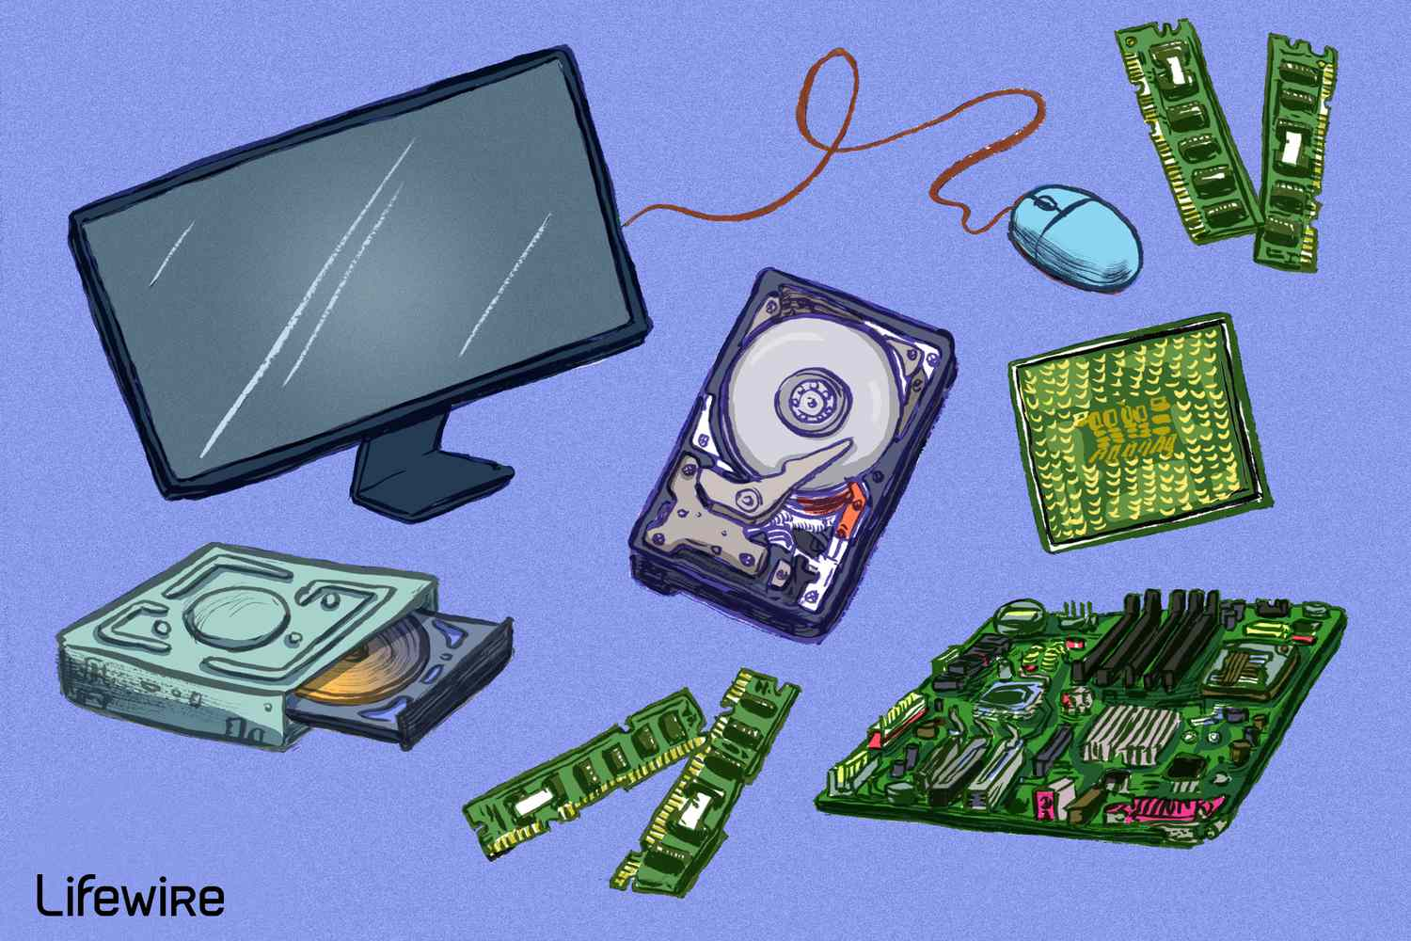

* 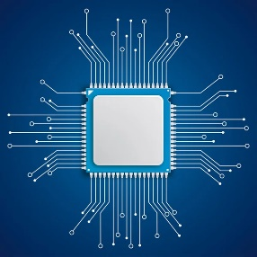**Central Processing Unit (CPU):**

The Central Processing Unit (CPU) is often referred to as the "brain" of a computer. It is a hardware component responsible for executing instructions and performing calculations in a computer system. The CPU interprets and carries out instructions from computer programs, making it the most critical part of any computing device.

The CPU is composed of several key elements:

* Control Unit: This component manages the execution of instructions by coordinating and controlling the flow of data between various hardware components.
* Arithmetic Logic Unit (ALU): The ALU is responsible for performing arithmetic operations (e.g., addition, subtraction, multiplication, division) and logical operations (e.g., AND, OR, NOT) required for processing data.
* Registers: These are small, fast storage locations within the CPU that temporarily hold data and instructions being processed. Registers are crucial for the CPU's efficient operation.
* Cache Memory: Cache is a small, high-speed memory integrated into the CPU, used to store frequently accessed data or instructions, which helps reduce the time needed to fetch data from the slower main memory (RAM).
* Clock: The CPU operates based on a clock that synchronizes the processing of instructions and dictates the speed at which computations take place, measured in gigahertz (GHz)
* **Input Devices:**

Input devices are hardware peripherals that enable users to interact with a computer system by providing data or commands. Some common input devices include:

* **Keyboard:** A typewriter-style device with keys representing letters, numbers, and symbols, allowing users to input text and commands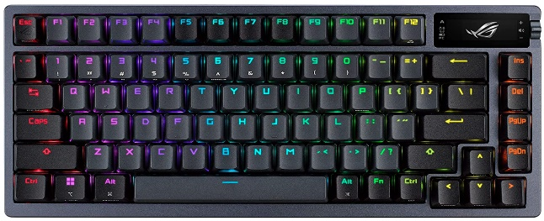
* **Mouse:** A pointing device that allows users to move a cursor on the screen, click, and interact with graphical user interfaces. 
* **Touchscreen:** A display panel that can detect touch gestures, allowing direct interaction with the computer screen.

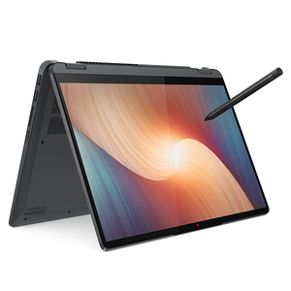

* **Trackpad:** Similar to a touchscreen, it enables users to control the cursor and perform gestures using their fingers.

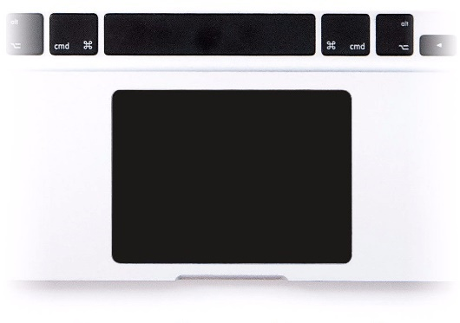

* **Joystick/Gamepad:** Primarily used for gaming, these devices provide precise control for navigating virtual environments.



* **Scanner:** Used to convert physical documents or images into digital formats, which can be stored and manipulated on a computer.

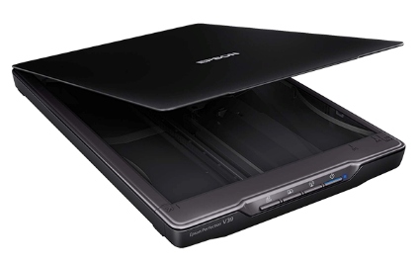

* **Webcam:** A camera used for capturing video and images, commonly used for video conferencing and recording videos.



* **Microphone:** An audio input device used to record sound, voice commands, or for communication purposes



* **Output Devices**:

Output devices display or present processed data and information from the computer to the user. Common output devices include:

* **Monitor/Display:** A visual output device that displays text, images, videos, and graphics generated by the computer.



* **Printer:** Used to produce hard copies of digital documents, images, or graphics on paper or other media.

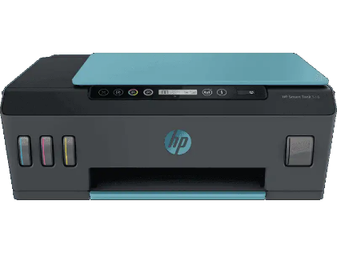

* **Speakers/Headphones:** Audio output devices used for playing sound, music, or conveying system alerts and notifications.



* **Projector:** Used to project computer-generated content onto a larger screen or surface for presentations and media viewing.



* **Motherboard:**

The motherboard, also known as the mainboard or system board, is a central printed circuit board (PCB) that serves as the backbone of a computer. It provides a platform for various hardware components to connect and communicate with each other. The motherboard is vital for the computer's overall functionality and determines the compatibility of other components.

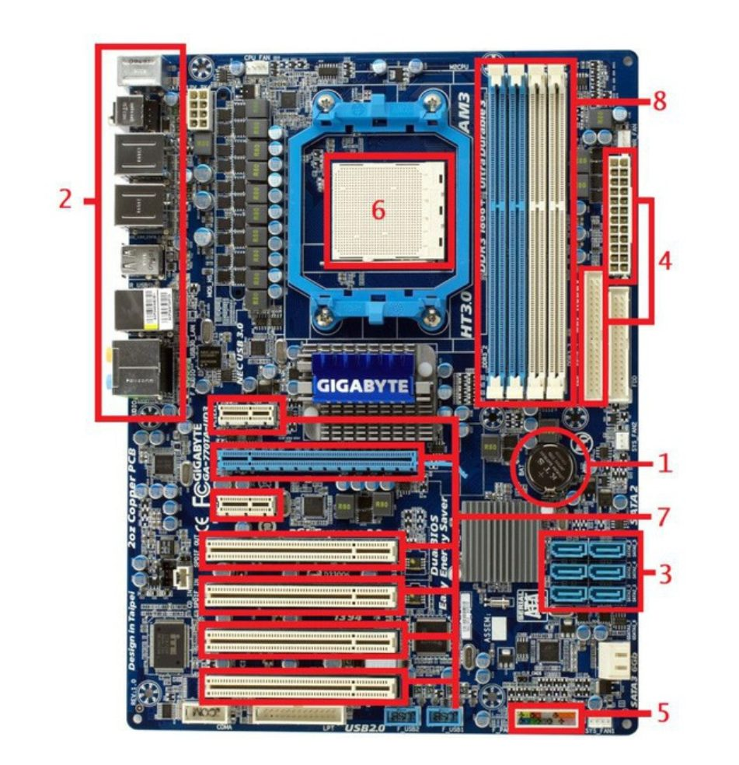

Motherboard Components:

1. **CMOS/BIOS:**

Bios (BIOS or Basic Input Output System) is where all the data and settings of the motherboard are stored. It can be updated, changed.

CMOS (Complementary Metal Oxide Semi-Conductor) is a type of battery system that retains data when the entire system is turned off. After a failed update or if you want to increase the efficiency of your RAM, the CMOS battery can be removed to reset the BIOS.

1. **Input/output Port:**

* Microphone/Speaker Port
* Monitor - VGA, HDMI Port
* Ethernet Cable Port
* USB port
* Some modern motherboards have a Type-C port

1. **Storage Device Connector:**

Here the Hard disk/SSD resides. The integrated drive electronics is the 40-pin male connector where the HDD is connected. The Serial Advanced Technology Attachment is the 7-pin connector that houses the SSD. This is modern technology and works faster.

1. **Power connector:**

There is a 20-24 pin female connector named ATX (Advanced Technology extended). Through this, there is power connection to the motherboard and it draws the required power directly from the power supply.

1. **Front I/O connector:**

You connect the power switch, LED power indicator, reset switch, and HDD LED cables here. The front audio port and front USB are also connected here.

1. **CPU socket:**

Your CPU (processor) is installed here. This is where data processing and transfer take place. Your CPU is one of the most important parts of your computer, so you often choose your motherboard based on compatibility with the CPU you want to use. The CPU needs to be 100% compatible with the motherboard socket in order to work.

1. **Expandable Card Slot:**

Expansion card slots are used when you add additional accessories such as a video card, network card, audio card or PCIe SSD. The slots are located on the lower half of the motherboard, below the CPU socket.

* **Video Card Slot:** The video card slot allows you to increase the graphical performance of your computer by installing a dedicated GPU that can provide better graphical performance than AMD APUs or Intel CPUs.
* **Network Card Slot:** Network card slot Where you put the network interface card (NIC). It allows you to connect to other computer networks via LAN or Internet. There is an RJ-45 port at the back.
* **Audio Card Slot:** Here fit audio cards. They convert electrical signals into audio signals that we can hear. Different types of ports are found on the back depending on the type of audio

1. **RAM Slot:**

RAM, or Random Access Memory, is one of the most important components of a motherboard in slots. RAM modules are placed in RAM slots. There are SIMM slots (single in-line memory modules) that support only a 32-bit bus, and there are DIMM slots (dual inline memory modules) that simultaneously support a 64-bit bus.

1. **Northbridge and Southbridge Chip:**

The Northbridge chip is directly integrated into the CPU and handles fast communication between the CPU and performance-sensitive components such as the graphics card and system memory. It is also connected to the Southbridge chip which also acts as a communication hub. However, the Southbridge communicates with less performance-sensitive components such as USB ports, storage devices, on-board networks and audio chips.

**3.2 STORAGE MEDIA AND HEALTH DIAGNOSTICS**

**INTRODUCTION**

Storage media refers to the physical devices or media used for storing and preserving data in digital format. In the realm of computing and information technology, the need for efficient and reliable data storage has become paramount. Storage media plays a crucial role in various aspects of modern technology, from personal computing to large-scale data centres, cloud storage, and enterprise-level data management. The evolution of storage media has witnessed significant advancements, leading to increased capacities, improved performance, and enhanced data security.

**IMPORTANCE**

The importance of storage media lies in its role as a fundamental component of information technology. Whether it's storing operating systems, software applications, multimedia files, or crucial business data, efficient and reliable storage is critical for several reasons such as Data Preservation, Data Backup and Recovery, Data Mobility, Data Sharing and Collaboration, Application and System Performance, Data Security

**STORAGE MEDIA:**

There are various types of storage media available, each with its own characteristics, advantages, and use cases. Below are some of the most commonly used storage media:

* **Hard Disk Drive (HDD):**

HDDs use magnetic storage to store data on rotating platters. They have been a primary storage choice for decades due to their high capacity and relatively lower cost per gigabyte. However, HDDs are mechanical devices with moving parts, making them more susceptible to mechanical failures and slower than newer alternatives.

* **Solid State Drive (SSD):**

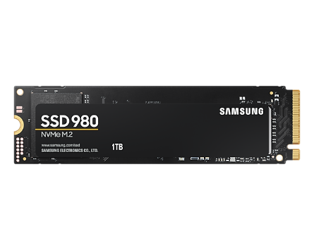SSDs use flash memory to store data, offering faster read and write speeds compared to HDDs. They are more durable since they have no moving parts, making them less prone to physical damage. SSDs have become increasingly popular in laptops, desktops, and servers, where speed and reliability are crucial.

* **Optical Discs:**

Optical storage media includes CDs (Compact Discs), DVDs (Digital Versatile Discs), and Blu-ray discs. These discs use lasers to read and write data. While their popularity has decreased with the rise of faster and higher capacity storage options, they are still used for distributing software, movies, and music.

* **USB Flash Drives:**

USB flash drives, also known as thumb drives or memory sticks, are portable storage devices that connect to a computer's USB port. They are small, lightweight, and offer convenience for data transfer between devices.

* 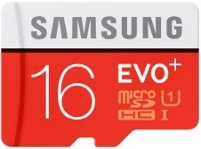**Memory Cards:**

Memory cards are used in digital cameras, smartphones, tablets, and other portable devices to store data, such as photos, videos, and music. Common formats include SD cards, microSD cards, and CompactFlash cards.

* **Cloud Storage:**

Cloud storage involves storing data on remote servers accessed over the internet. Users can upload, download, and synchronize their data to the cloud, providing accessibility from any device with an internet connection.

**Types of HDD and SSD**

HDD:

* **3.5-inch Desktop HDD:**

These are standard-sized HDDs commonly used in desktop computers. They offer higher capacities and are suitable for desktop systems where space and power consumption are less critical.

* **2.5-inch Laptop HDD:**

These smaller-sized HDDs are designed to fit into laptops and other portable devices. They are more compact and energy-efficient, making them suitable for laptops and portable external storage solutions.

* **Enterprise HDD:**

Enterprise HDDs are built for data centers and server environments. They often have higher reliability, faster performance, and may include advanced features like dual-port connections for redundancy.

* **NAS HDD:**

Network-Attached Storage (NAS) HDDs are designed specifically for use in NAS devices. They are optimized for continuous operation and can handle multiple read and write requests from multiple users simultaneously.

* **Surveillance HDD:**

Surveillance HDDs are tailored for use in video surveillance systems. They are optimized for continuous writing and support multiple video streams simultaneously.

SSD:

1. **SATA SSD:** SATA (Serial ATA) SSDs are the most common type of SSDs and use the same interface as traditional HDDs. They provide faster performance than HDDs but are limited by the SATA interface's maximum data transfer rate.
2. **PCIe SSD:** PCIe (Peripheral Component Interconnect Express) SSDs connect directly to the motherboard through PCIe slots, offering faster data transfer rates compared to SATA SSDs. They come in different form factors like M.2 and PCIe add-in cards.
3. **NVMe SSD:** NVMe (Non-Volatile Memory Express) SSDs are a subset of PCIe SSDs designed to take full advantage of the NVMe protocol. NVMe enables faster data transfer and lower latency, making these SSDs extremely fast and ideal for high-performance computing tasks.
4. **M.2 SSD:** M.2 is a small, compact form factor used in modern laptops and desktops. M.2 SSDs can use either the SATA or PCIe interface, with NVMe M.2 SSDs offering the highest performance.

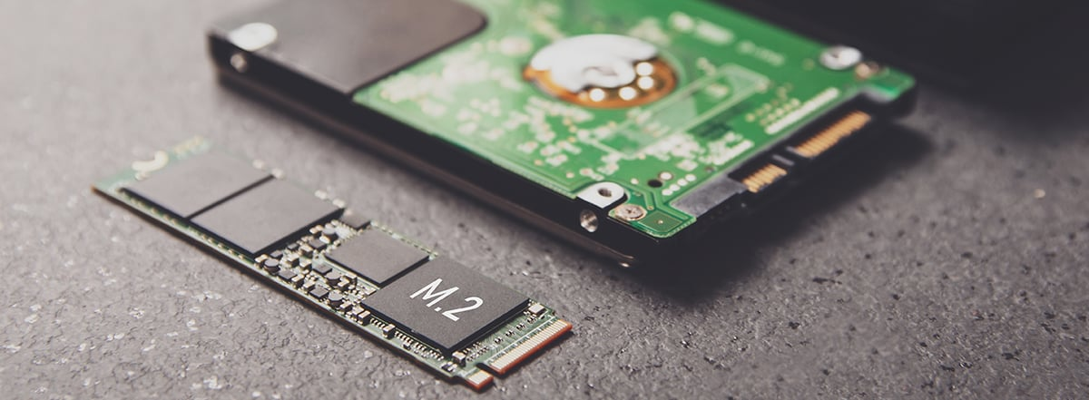

|  |  |  |
| --- | --- | --- |
| Aspect | HDD (Hard Disk Drive) | SSD (Solid State Drive) |
| Technology | Uses magnetic storage with spinning platters | Uses flash memory with no moving parts |
| Performance | Slower access and data transfer speeds | Faster access and data transfer speeds |
| Reliability | More susceptible to physical damage and failures | More reliable with no moving parts |
| Power Consumption | Consumes more power due to mechanical parts | Consumes less power with no moving parts |
| Noise | Produces noise due to spinning platters | Completely silent with no moving parts |
| Cost | Generally, more affordable per storage capacity | Generally more expensive, especially for larger sizes |
| Capacity | Offers larger storage capacities | Available in various sizes, but still smaller |
| Form Factor | Available in 3.5-inch and 2.5-inch form factors | Available in various form factors, including M.2 |
| Use Cases | Common in desktops and some laptops | Increasingly used in laptops and portable devices |
| Application Speed | Slower application loading times | Faster application loading times |
| Boot Times | Longer boot times | Shorter boot times |
| Durability | Prone to physical wear and tear | More durable and shock-resistant |
| Heat Generation | Generates more heat due to moving parts | Generates less heat with no moving parts |

**Diagnosing Storage Media:**

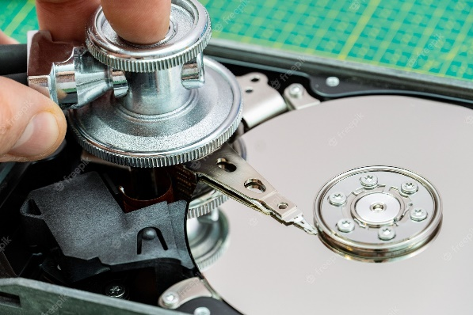In today's digital age, storage media plays a crucial role in our lives, be it for personal or professional use. Hard Disk Drives (HDDs) and Solid State Drives (SSDs) are the primary types of storage devices used in computers and other electronic devices to store data. However, like any other hardware component, storage media can experience wear and tear over time, which may lead to data loss or system failures. Therefore, it is essential to regularly check the health of your storage media to ensure the safety and integrity of your data.

Benefits of Regularly Checking Storage Media Health:

* **Early Detection of Issues:** Monitoring storage health helps in detecting early signs of potential failures, such as bad sectors, read/write errors, or temperature anomalies. Identifying these problems early allows for preventive measures to be taken, minimizing the risk of data loss and system crashes.
* **Data Backup and Recovery:** By regularly checking the health of your storage media, you can ensure that your data is backed up and recoverable in case of hardware failure. This is especially crucial for critical data and files.
* **Performance Optimization:** Identifying performance issues in storage devices allows users to take appropriate actions to optimize the system's overall performance, ensuring faster data access and reduced loading times for applications.
* **Prolonged Lifespan:** Monitoring storage health and taking necessary precautions can extend the lifespan of your storage media, avoiding premature failures and the need for frequent replacements.

**Tools and Techniques for Checking Storage Media Health:**

* **S.M.A.R.T. (Self-Monitoring, Analysis, and Reporting Technology):**

S.M.A.R.T. is a built-in feature present in most modern HDDs and SSDs. It monitors various parameters related to the drive's health, such as temperature, bad sectors, read/write errors, spin-up time, and more. There are numerous third-party tools and software that can retrieve and interpret S.M.A.R.T. data to assess the health of your storage media.

* **Manufacturer's Software:**

Many storage device manufacturers provide dedicated software to monitor and manage their products. These utilities often include diagnostic tools and health status indicators specific to their drives.

* **Third-Party Software:**

There are several third-party software applications available that can analyze and report on the health of your storage media. Some popular options include CrystalDiskInfo, and HD Sentinel.

* **Operating System Utilities:**

Some operating systems offer built-in tools to check storage health. For example, Windows has the "chkdsk" (Check Disk) utility that can scan and repair file system errors on HDDs. Linux and macOS have similar utilities.

**Tips to Maintain Storage Devices:**

* **Keep the System Cool:** High temperatures can accelerate wear on storage media. Ensure proper ventilation and cooling for your computer to prevent overheating of storage devices.
* **Avoid Physical Shocks:** Protect your storage devices from physical shocks and impacts, especially when the system is in use. Transport external storage devices with care and consider using shockproof cases.
* **Regular Data Backups:** Always keep backup copies of your important data on separate storage media or cloud storage to ensure data recovery in case of a storage failure.
* **Update Firmware and Drivers:** Periodically check for firmware updates for your storage devices and keep your system's drivers up to date. Manufacturers often release updates to improve performance and fix bugs.
* **Avoid Power Surges:** Use surge protectors or uninterruptible power supply (UPS) systems to protect your system and storage devices from sudden power fluctuations and outages.
* **Secure Erase for SSDs:** If you plan to sell or dispose of an SSD, use the manufacturer's secure erase utility to wipe all data securely. This ensures that no sensitive information remains on the drive.

**3.3 VIRUS & ANTIVIRUS**

**INTRODUCTION**

In the context of computers and digital technology, the terms "virus" and "antivirus" refer to malicious software and protective software, respectively. Computer viruses are malicious programs designed to replicate and spread, often causing harm to computer systems, data, and networks. Antivirus software, on the other hand, is designed to detect, prevent, and remove viruses and other malicious software from computers and networks

**IMPORTANCE**

The importance of understanding viruses and using antivirus software stems from the increasing reliance on digital technology and the internet in our daily lives. Viruses can cause significant disruptions, financial losses, data breaches, and identity theft. They can also be used for espionage, stealing sensitive information, and launching large-scale attacks on critical infrastructure. Antivirus software is crucial for protecting computers and networks from these threats, safeguarding personal and business data, and ensuring the smooth functioning of digital operations.

**VIRUS**

In the context of computing, a virus is a type of malicious software that attaches itself to legitimate programs or files, infecting them and replicating to other systems when the infected file or program is executed. Viruses can spread through various means, including email attachments, infected downloads, and compromised websites. Once activated, they can perform harmful actions such as corrupting files, stealing data, or damaging the system.

**Types of Viruses:**

There are several types of computer viruses, each with its specific characteristics and behaviors. Some common types include:

* **File Infector Viruses:**

These viruses attach themselves to executable files and propagate when the infected file is executed.

* **Macro Viruses:**

Macro viruses infect applications like Microsoft Office documents (Word, Excel) that contain macros, and they spread when these macros are executed.

* **Boot Sector Viruses:**

These viruses infect the boot sector of a computer's storage device (e.g., hard disk, USB drive) and activate when the computer starts up.

* **Polymorphic Viruses:**

Polymorphic viruses can change their code or appearance to avoid detection by antivirus software.

* **Worms:**

Worms are self-replicating programs that spread over networks and can cause a massive outbreak by exploiting vulnerabilities.

* **Trojan Horses:**

Trojans disguise themselves as legitimate software but have malicious intentions, such as providing unauthorized access to a computer or stealing data.

**ANTIVIRUS**

Antivirus (or anti-malware) software is a protective software designed to detect, prevent, and remove malicious software, including viruses, worms, Trojans, ransomware, and more. Antivirus programs use a combination of signature-based detection, behavioural analysis, heuristics, and machine learning to identify and neutralize threats in real-time.

**Working:**

The working of antivirus software can be summarized in a few simple steps:

1. **Scanning Files:** When you install an antivirus program, it starts by scanning your computer's files and programs for known virus signatures. These signatures are unique patterns or codes that are associated with specific malware.
2. **Virus Definitions:** The antivirus software maintains a database of virus definitions, which contains information about known viruses and malware. These definitions are regularly updated by the antivirus vendor to keep up with new threats.
3. **Real-Time Protection:** Once the initial scan is complete, the antivirus software remains active in the background, providing real-time protection. Whenever you access a file, download something from the internet, or run a program, the antivirus checks it against the virus definitions.
4. **Detection and Quarantine:** If the antivirus detects a file or program with a matching virus signature, it will take action to prevent the virus from causing harm. In most cases, the antivirus will quarantine the infected file, isolating it from the rest of the system to prevent further spread.
5. **Heuristics and Behavioral Analysis:** In addition to using virus definitions, some advanced antivirus programs use heuristics and behavioral analysis. Heuristics involves looking for behaviors or characteristics commonly associated with malware, even if no specific virus signature is known.
6. **Automatic Updates:** To stay effective against new and emerging threats, antivirus software regularly updates its virus definitions. These updates are usually automatic and happen in the background, ensuring that the antivirus can recognize and protect against the latest malware.
7. **User Actions:** Sometimes, the antivirus may encounter a file or program that it's not sure about (false positives). In such cases, the user may be prompted to take action, such as allowing the program, sending the file for further analysis, or quarantining it.
8. **On-Demand Scans:** In addition to real-time protection, antivirus software allows users to perform manual or scheduled scans. These on-demand scans can be quick scans for specific files or folders or full system scans to check the entire computer.

Different Antivirus Softwares:

1. **Norton Antivirus:** Norton is a well-established antivirus software known for its comprehensive protection, including antivirus, firewall, identity theft protection, and more. It offers various plans for individuals and businesses.
2. **McAfee Antivirus:** McAfee provides robust antivirus protection with features like anti-malware, firewall, and anti-phishing. They offer plans for different devices and platforms, including Windows, Mac, Android, and iOS.
3. 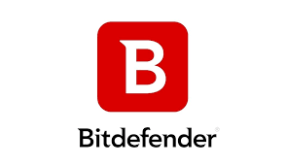**Bitdefender Antivirus:** Bitdefender is known for its excellent malware detection and minimal impact on system performance. It offers various packages for different levels of protection.
4. **Kaspersky Antivirus:** Kaspersky is a popular choice for its reliable antivirus protection and features like real-time scanning, system cleanup tools, and more.
5. **Avast Antivirus:** Avast offers a free antivirus version along with premium plans. It provides essential protection against viruses and malware and has a user-friendly interface.
6. **AVG Antivirus:**

AVG, now owned by Avast, is another widely used antivirus software offering free and paid versions with solid virus protection.

**3.4 OSI MODEL: NETWORK LAYERING**

**INTRODUCTION**

The OSI (Open Systems Interconnection) model serves as a fundamental framework for understanding the communication processes within computer networks. It outlines a structured approach to network design and communication protocols, aiding in the seamless exchange of data across various networked devices and systems.

**IMPORTANCE**

The OSI model provides a standardized way to conceptualize and discuss networking concepts. It enables network engineers and professionals to comprehend, troubleshoot, and develop network solutions effectively. By breaking down the communication process into distinct layers, the model facilitates the identification and resolution of issues at specific levels.

**LAYERS OF THE OSI MODEL**

* **Physical Layer:** Deals with the physical medium of data transmission. It defines specifications for cables, connectors, and signals.
* **Data Link Layer:** Focuses on framing data into frames for reliable transmission over the physical layer. It handles error detection and correction.
* **Network Layer:** Manages the routing and addressing of data packets. It enables data to traverse multiple networks.
* **Transport Layer:** Ensures end-to-end communication and data segmentation. It manages flow control and error recovery.
* **Session Layer:** Establishes, maintains, and terminates communication sessions between devices.
* **Presentation Layer:** Handles data translation, encryption, and compression, ensuring compatibility between different systems.
* **Application Layer:** Provides network services directly to end-users, including functions such as file transfer, email, and web browsing.

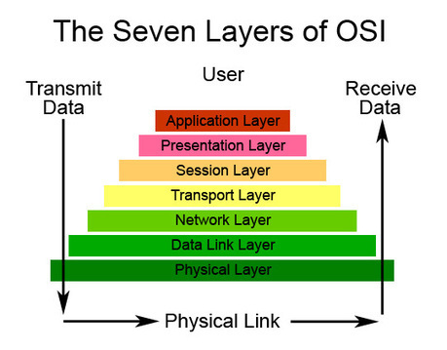

**TYPES OF NETWORKING DEVICES AND EXPLANATIONS**

* 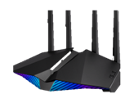**Router:**

A router is a networking device that connects different networks together and directs data packets between them. It determines the optimal path for data transmission based on IP addresses. Routers provide gateway functionality, enabling devices to communicate across different networks, such as local area networks (LANs) and wide area networks (WANs).

**Key Functions of a Routers:**

* **Packet Forwarding:** Routers analyze destination IP addresses in data packets and forward them to the appropriate network segment.
* **Network Address Translation (NAT):** Routers modify source or destination IP addresses to enable communication between networks with conflicting address spaces.
* **Routing Protocols:** Routers use dynamic routing protocols to update and share routing information, ensuring efficient data delivery.
* **Switch:**

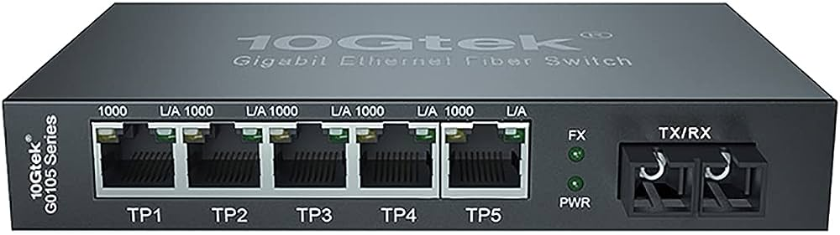A switch is a device that operates at the data link layer of the OSI model and connects devices within a local network (LAN). Unlike hubs, switches intelligently forward data to the specific device based on its MAC address, enhancing network efficiency and reducing collisions.

**Key Functions of a Switch:**

* **MAC Address Learning:** Switches build and maintain a MAC address table, associating MAC addresses with specific switch ports for efficient data forwarding.
* **Broadcast Management:** By forwarding data only to the relevant port, switches prevent unnecessary broadcast traffic from flooding the entire network.
* **VLAN Support:** Switches can segregate network traffic into virtual LANs (VLANs), enhancing network organization and security.
* **Hub:**

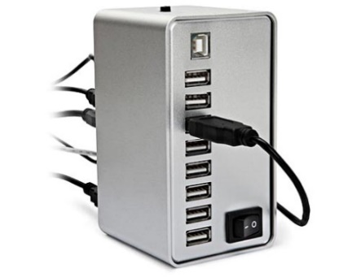A hub is a basic networking device that connects multiple devices in a network. However, it lacks the intelligence of switches and routers. Data received by a hub is broadcasted to all devices connected to it, leading to inefficient use of network bandwidth.

**Key Function of a Hub:**

* **Data Distribution:** Hubs indiscriminately distribute incoming data signals to all devices connected to the hub, leading to potential network collisions and inefficiencies.
* **Gateway:**

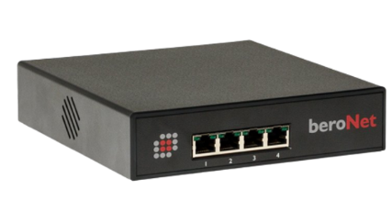A gateway is a networking device that acts as an interface between two different networks, facilitating data transmission and enabling communication between devices with different protocols or architectures. Gateways play a pivotal role in connecting networks of varying types, such as local area networks (LANs) to wide area networks (WANs) or connecting different network protocols.

**Key Functions of a Gateway:**

* **Protocol Translation:** Gateways enable communication between networks with distinct protocols, translating data as needed for compatibility.
* **Network Address Translation (NAT):** Gateways modify source or destination IP addresses to ensure smooth data flow between networks with conflicting address spaces.
* **Security Enforcement:** Many gateways include firewall capabilities, enforcing security policies and filtering traffic to protect networks from unauthorized access.
* **Bridge**:

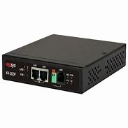A bridge is a device that operates at the data link layer (Layer 2) of the OSI model and connects two or more segments of a network to form a single network. Bridges efficiently manage network traffic by examining MAC addresses and making forwarding decisions. They help reduce network congestion and optimize data transmission within the same network.

**Key Functions of a Bridge:**

* **Segmentation:** Bridges divide a network into smaller segments, reducing the scope of network collisions and enhancing overall performance.
* **MAC Address Filtering:** By examining MAC addresses, bridges intelligently forward data only to the segment where the intended recipient resides.
* **Broadcast Isolation:** Bridges prevent unnecessary broadcast traffic from propagating across the entire network, reducing network congestion.
* **Repeater:**

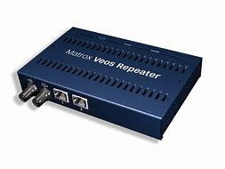A repeater is a simple networking device that operates at the physical layer (Layer 1) of the OSI model. Its primary function is to regenerate and amplify network signals to overcome attenuation and extend the distance over which signals can travel. Repeaters are particularly beneficial in environments where long cable runs are necessary.

**Key Functions of a Repeater:**

* **Signal Amplification**: Repeaters receive weakened signals, amplify them, and retransmit them at a higher power level, effectively extending the reach of the network.
* **Signal Regeneration:** In addition to amplification, repeaters regenerate signals to ensure that they remain clear and intelligible, minimizing data corruption

**3.5 DIGITAL MARKETING**

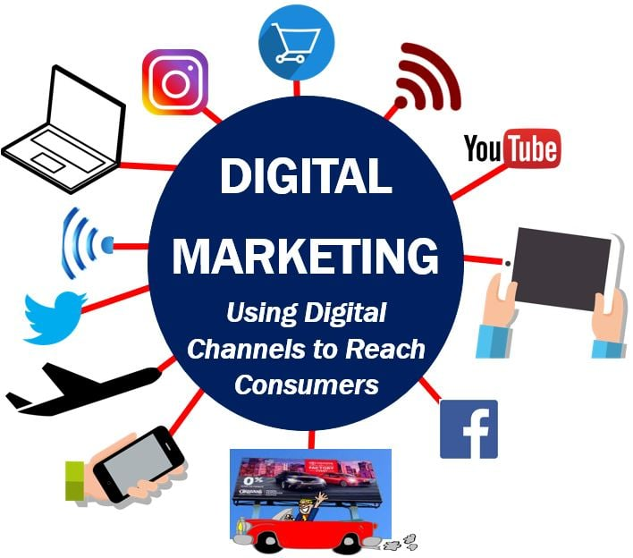**INTRODUCTION**

Digital marketing refers to the use of digital channels, platforms, and technologies to promote and advertise products, services, brands, or ideas to a target audience.

It encompasses a wide range of online strategies and tactics aimed at reaching potential customers and engaging with them through various digital mediums.

**IMPORTANCE**

Digital marketing offers numerous advantages for businesses and individuals looking to promote their products, services, or ideas. Some of the key advantages of digital marketing include:

* Global reach
* Cost-effectiveness
* Targeted audience
* Measurable results
* Flexibility and optimization
* Engagement and interaction
* Personalization
* Higher conversion rates
* 24/7 availability
* Brand building

**COMPONENTS OF DIGITAL MARKETING**

Key components of digital marketing include:

* **Search Engine Optimization (SEO):** Optimizing websites and online content to improve their visibility in search engine results. The goal is to increase organic (non-paid) traffic to a website.
* **Social Media Marketing:** Utilizing social media platforms such as Facebook, Instagram, Twitter, LinkedIn, and more to connect with audiences, share content, and run targeted advertising campaigns.
* **Content Marketing:** Creating and sharing valuable, relevant, and consistent content to attract and engage a defined target audience. This can include blog posts, videos, infographics, and more.
* **Pay-Per-Click (PPC) Advertising:** Running paid advertising campaigns on platforms like Google Ads or social media platforms. Advertisers pay a fee each time their ad is clicked.
* **Email Marketing:** Sending targeted emails to a list of subscribers to promote products, services, or provide valuable content. This can help build customer relationships and drive conversions.
* **Influencer Marketing:** Collaborating with individuals who have a significant online following (influencers) to promote products or services. This leverages the influencer's credibility and reach.
* **Affiliate Marketing:** Partnering with other businesses or individuals (affiliates) who promote your products or services in exchange for a commission on sales generated through their efforts.
* **Online Public Relations (PR):** Managing a brand's online reputation and engaging with online media, blogs, and forums to shape public perception.
* **Social Media Management:** Creating, scheduling, and managing content across various social media platforms to build and maintain a brand's online presence.
* **Analytics and Data Analysis:** Monitoring and analyzing data from digital marketing efforts to measure performance, understand audience behavior, and optimize strategies for better results.

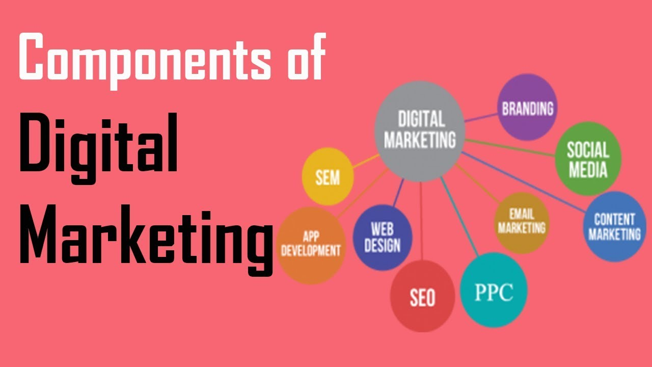

**SEARCH ENGINE OPTIMIZATION (SEO)**

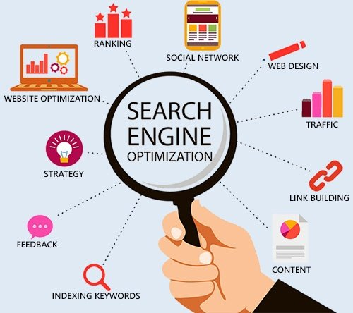It is the practice of optimizing a website or web pages to improve their visibility and ranking on search engine results pages (SERPs). The primary goal of SEO is to increase organic, non-paid, or natural traffic to a website by making it more accessible to search engines and relevant to users' search queries. Search engines like Google, Bing, and others use complex algorithms to determine the most relevant and valuable content for a given search query. SEO involves various techniques and strategies to align a website's content, structure, and overall online presence with these algorithms' criteria. By doing so, websites can improve their chances of appearing higher in the search results, which, in turn, can lead to increased traffic and potential customers.

**How SEO Works:**

* **Keyword Research:** SEO begins with identifying the keywords and phrases that users are likely to search for when looking for products, services, or information related to your website.
* **On-Page Optimization:**
  + **Content:** Create high-quality, relevant, and valuable content that incorporates the chosen keywords naturally. This content can include blog posts, articles, product descriptions, and more.
  + **Title Tags and Meta Descriptions:** Craft compelling and descriptive title tags and meta descriptions that include target keywords. These elements appear in search results and impact click-through rates.
  + **Headers (H1, H2, etc.):** Use headers to structure your content. They make it easier for search engines and users to understand the hierarchy of information on your page.
* **Technical SEO:**
  + **Website Speed:** Ensure your website loads quickly, as slow-loading sites can lead to higher bounce rates.
  + **Mobile-Friendliness:** Ensure your website is responsive and displays properly on mobile devices.
  + **Crawling and Indexing:** Help search engines index your site's pages by creating a clear sitemap and using a robots.txt file.
  + **URL Structure:** Use descriptive and user-friendly URLs that include relevant keywords.
* **Off-Page Optimization:**
  + **Backlinks:** Acquire high-quality backlinks from reputable websites. Backlinks are like "votes" for your website's credibility.
  + **Social Signals:** Engage with social media and build a presence. While social signals themselves don't directly impact SEO, they can indirectly boost visibility and traffic.
* **User Experience (UX):**
  + **Navigation:** Create a user-friendly navigation structure that allows visitors to easily find what they're looking for.
  + **Readability:** Make sure your content is easy to read and understand.
  + **Mobile Experience:** Ensure a smooth and intuitive experience for mobile users.
* **Content Freshness and Updates:**
  + Regularly update and refresh your content to keep it relevant and informative.
  + Adding new content, such as blog posts or articles, shows search engines that your website is active and engaging.
* **Search Engine Crawling and Indexing:**
  + Search engines use automated bots (crawlers) to scan websites and index their content. The more effectively your site is structured and optimized, the easier it is for these bots to understand and index your content.
* **Ranking Algorithms:**
  + Search engines use complex algorithms to determine the relevance and quality of websites in response to user searches. Factors like keywords, backlinks, user experience, and content quality all play a role in these algorithms.
* **Search Results Display:**
  + Based on the algorithm's assessment of your site, search engines display your pages in search results. The goal of SEO is to have your pages rank higher for relevant keywords, leading to increased visibility and traffic.

**3.6 ENTREPRENEURSHIP DEVELOPMENT**

**INTRODUCTION**

Entrepreneurship is when an individual who has an idea act on that idea, usually to disrupt the current market with a new product or service. Entrepreneurship usually starts as a small business but the long-term vision is much greater, to seek high profits and capture market share with an innovative new idea.

Entrepreneurship plays a crucial role in driving economic growth, job creation, and technological advancements. It involves traits such as vision, risk-taking, innovation, perseverance, and adaptability. Successful entrepreneurs often have a clear understanding of their goals and interests, and they actively seek ways to meet the needs of their target customers.

The entrepreneurial process includes idea generation, feasibility analysis, business planning, funding, launching the venture, growth, and adaptation to changing market conditions. Throughout this journey, entrepreneurs need to navigate challenges such as financial risk, market competition, and operational obstacles.

Entrepreneurship is supported by an ecosystem that includes government institutions, incubators, accelerators, educational programs, networking opportunities, and access to capital. The continuous growth and success of entrepreneurs rely on learning from failures, staying adaptable, and embracing innovation and technology.

Ultimately, entrepreneurship drives innovation, disrupts industries, and contributes to economic development while offering individuals the potential for personal fulfilment and financial success.

**TYPES OF ENTREPRENEURS**

* **Small Business Entrepreneur:** Focuses on starting and running small businesses with limited growth potential.
* **Scalable Startup Entrepreneur:** Aims to create a scalable business model with the potential for rapid growth and expansion.
* **Social Entrepreneur:** Seeks to address social or environmental issues while building a sustainable business.
* **Serial Entrepreneur:** Starts multiple ventures over their career, learning from each experience.

**OEM DEALERSHIP AND RETAILERS**

**What is OEM dealership?**

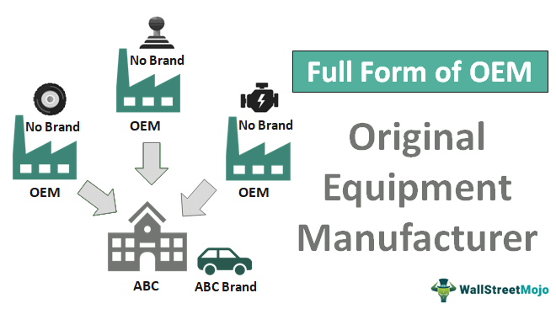An Original Equipment Manufacturer (OEM) dealership is a business arrangement where a manufacturer or producer of goods, often a large company, grants the right to sell its products under its brand name to another company or entity, known as the OEM dealer or distributor. The OEM dealer essentially acts as an authorized reseller or distributor of the manufacturer's products. In this type of dealership, the OEM provides the products to the dealer at wholesale prices, and the dealer is responsible for marketing, selling, and servicing those products to end customers. The OEM dealership agreement usually outlines the terms and conditions of the partnership, including pricing, distribution territories, marketing support, warranty terms, and any other relevant details.

**What are the advantages of purchasing from retailers having OEM dealership?**

* As mentioned above, legitimate companies provide the rights for dealers to sell their products under their brand name is called as OEM dealership. Because of this very reason we are assured of the quality that is to be expected from the products under a OEM brand
* Purchasing products from a brand for example HP, at their original website or showrooms and not any other selling platforms, may differ the prices margin significantly but the quality that is provided is surely appreciable.
* The providence of durability and performance is quick a sight in OEM products as they are managed to meet the standard expectations of both the market and the customers purchasing them, hence it is quite a good choice to buy from OEM dealers or from any OEM brand

**Truth behind Non-OEM dealers and retailers**

* Though this is a topic that is ignored most of the time, but when purchasing some electronic appliances we look for our budget and price, rather than considering the desire or the need by which we have to purchase the appliances, and because of that we end up purchasing something that is not meeting up to our standards .
* Most dealers that do not belong to OEM sell defective products; the products are not entirely defective but some parts are changed into cheap ones so that the price may go down something.
* They may be a little bit cheaper than OEM products but, if they work, they work pretty well, and we do not need to worry much if they are working but the situation changes when they stop working and gets corrupted or any other function occurs
* We can also identify this by what means they are providing us the way to claim the warranty for the product the customer purchased, if we are required to meet the dealer himself/herself in order to claim the warranty then it is the moment to be concerned,
* Legitimate ones will ask you to directly visit the service center of that particular brand in order to claim the warranty of that respective product
* Here is the simple example of a product from OEM as well as Non-OEM dealers,
  + OEM:

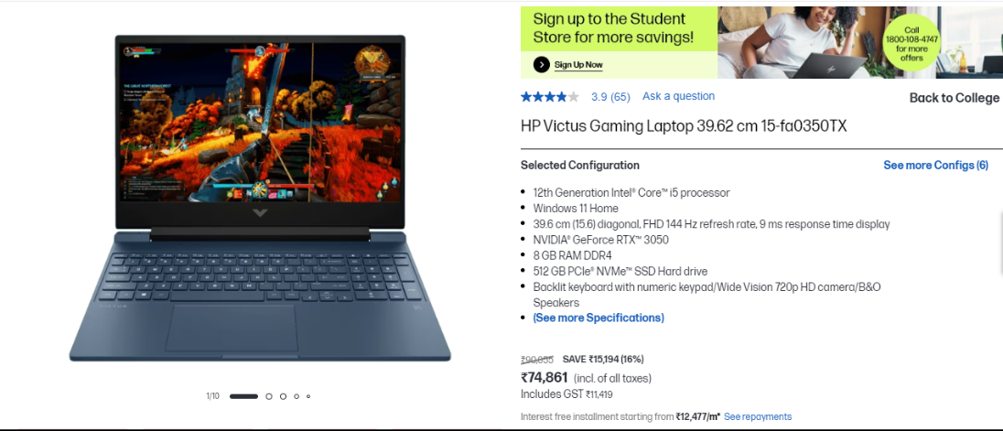

* + Non-OEM:



**SPEECHES AND NEGOTIATION SKILLS**

Delivering a speech effectively involves a combination of preparation, organization, and delivery skills.

Whether you're speaking in front of a large audience or in a more intimate setting, the following tips can help you deliver a compelling and impactful speech:

* **Know Your Audience:** Understand who your audience is and what they expect from your speech. Tailor your content and language to match their interests, knowledge level, and expectations.
* **Define Your Purpose:** Clarify the purpose of your speech. Are you trying to inform, persuade, inspire, or entertain your audience? Having a clear objective will guide your speech preparation.
* **Organize Your Content:** Structure your speech with a clear introduction, main points, and a conclusion. Consider using a storytelling approach or incorporating anecdotes to make your speech engaging.
* **Practice, Practice, Practice:** Rehearse your speech multiple times to become familiar with the content and flow. Practice in front of a mirror, record yourself, or deliver it to a friend for feedback.
* **Manage Your Time:** Be mindful of the allocated time for your speech. Avoid going too long or being too brief. Time yourself during practice to ensure you stay within the time limit.
* **Start Strong:** Begin your speech with a compelling opening. You can use a thought-provoking quote, a surprising fact, or a personal story to capture your audience's attention from the start.
* **Engage Your Audience:** Use eye contact, gestures, and facial expressions to connect with your audience. Engage them by asking rhetorical questions, involving them in your speech, or using humor where appropriate.
* **Speak Clearly and Pace Yourself:** Speak at a moderate pace, enunciate clearly, and avoid using jargon or overly complex language. This will make your speech more accessible and understandable to the audience.
* **Use Visual Aids (if applicable):** If you're using visual aids like slides, make sure they enhance your speech rather than overshadow it. Keep them simple, relevant, and visually appealing.
* **Stay Confident and Calm:** Nervousness is normal, but try to maintain your composure. Take deep breaths before speaking, and remember that the audience wants you to succeed.
* **Vary Your Tone and Voice:** Use variations in your tone and volume to add emphasis to important points and to maintain audience interest.
* **Stay on Message:** Stay focused on your main points and avoid going off on tangents. Keep your speech concise and to the point.
* **Address Questions Gracefully:** If you allow for questions at the end, be prepared to answer them confidently and succinctly.
* **Conclude Strongly:** Summarize your main points and end with a memorable closing statement that leaves a lasting impression.
* **Seek Feedback:** After delivering your speech, ask for feedback from trusted friends or colleagues. Constructive criticism can help you improve for future presentations.
* Remember that effective speech delivery improves with practice and experience. Stay authentic, be yourself, and believe in the value of your message. With time and effort, you can become a confident and persuasive speaker.

**CHAPTER 5**

**CONCLUSION**

During our industrial training, we explored hardware components like processors, memory, and circuits, understanding how they power modern technology. This hands-on experience highlighted the important link between hardware and software, driving progress.

In the digital marketing aspect, we learned different strategies such as SEO and social media. Creating content and studying user behavior showed us how to make marketing more effective. This training taught us how digital marketing boosts brand visibility and connects with diverse online audiences.

Regarding entrepreneurship, we gained insights from failures and understood key elements for success and ethical choices. We also learned about the legal and ethical factors that affect businesses, giving us a well-rounded view of how businesses operate.

In a nutshell, our training covered hardware, digital marketing, and entrepreneurship, emphasizing the merging of technology, smart marketing, and ethical business practices.